Fall Semester 2025-26
Lab Assignment – 1
Slot: L13+L14
Class: VL2025260105679
Branch: B.tech CSBS
Course code & title: CBS3005
Cloud, Microservices and Applications
Faculty name: Nithya K
DA by:
Kartikey Gupta
22BBS0105

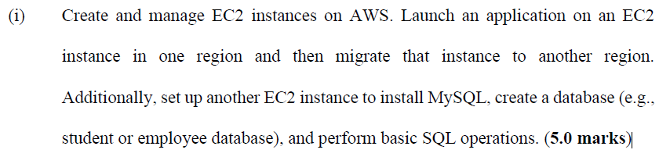
Part 1: Launch EC2 Instance for Static HTML App
1. Log in to AWS Console
- Go to EC2 Dashboard
2. Launch EC2 Instance
- Click Launch instance
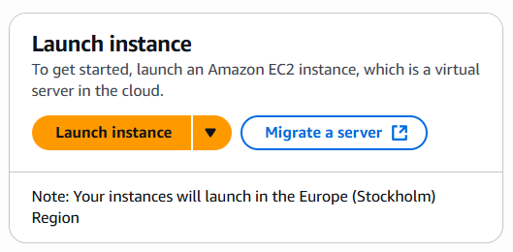
- Name: 22BBS0105_LA1
- AMI: Amazon Linux 2023 kernel-6.1
- Instance type: t3.micro
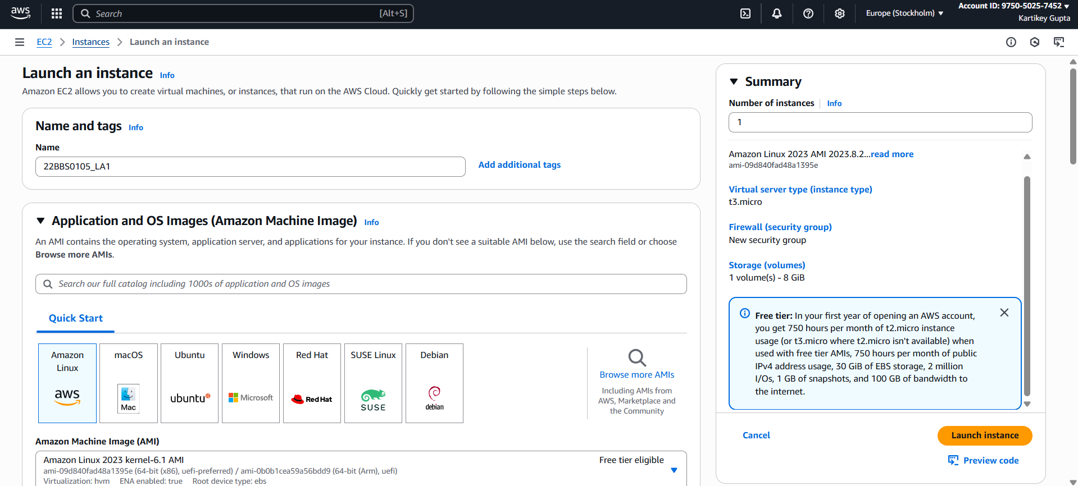
- Key pair: Create or select existing key
- Network settings:
  - Click Edit
  - Allow SSH (port 22) and HTTP (port 80)
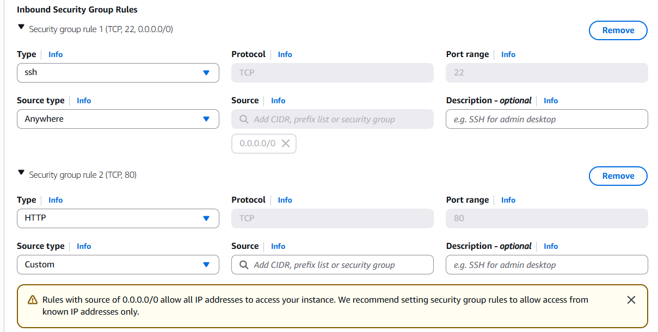
- Click Launch

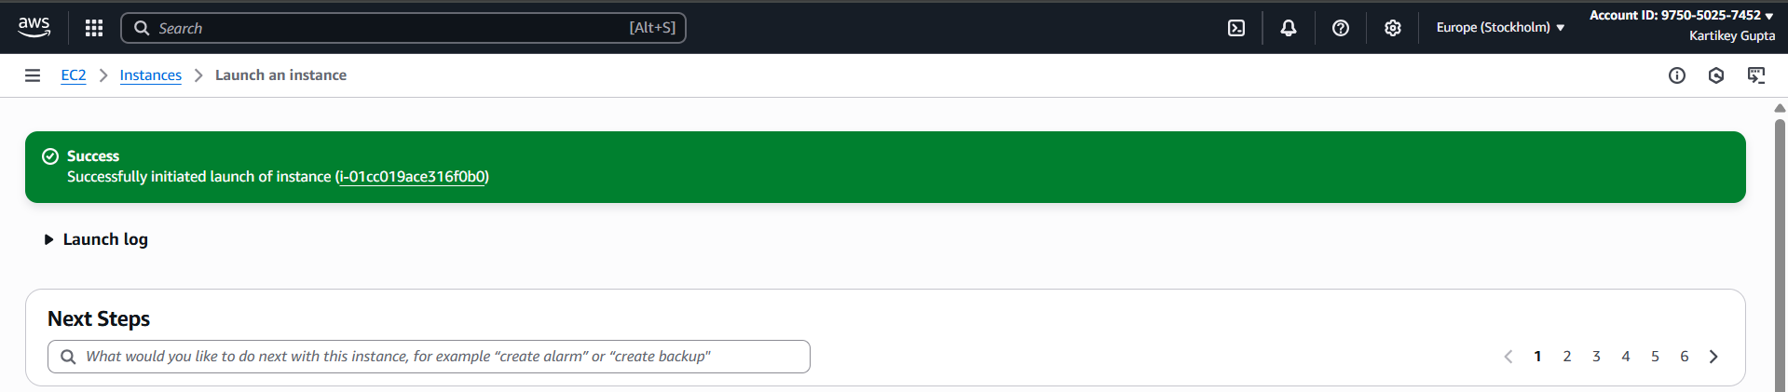

Step 2: Connecting to ec2 instance
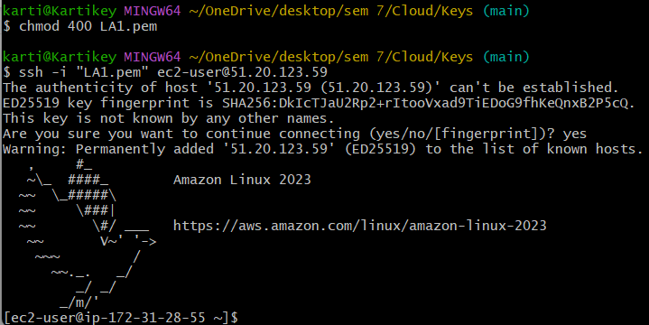
Step 3: Installing Apache
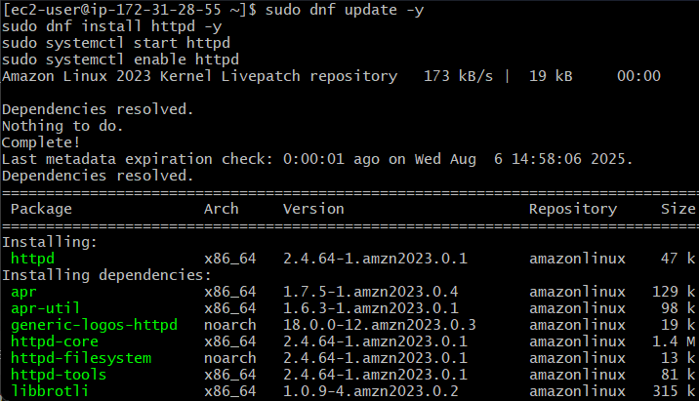
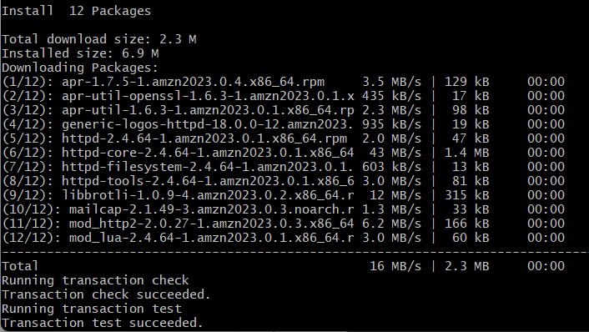
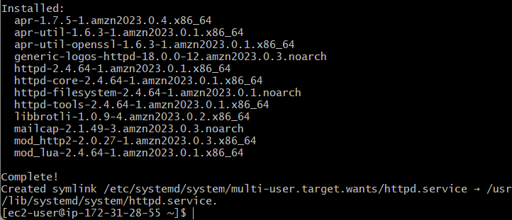
Checking if server is up and running
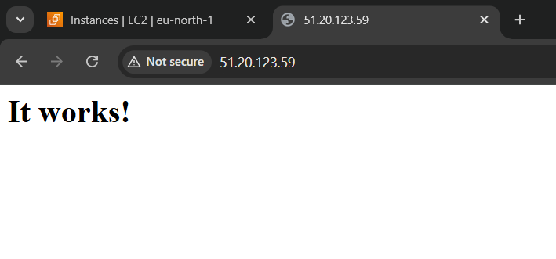
Working!!
Part 2: Migrate the Instance to Another Region
AWS doesn't allow direct region change, so we will copy the AMI.
1. Create Image (AMI)
- Go to EC2 → Instances → Select instance → Actions → Image → Create Image
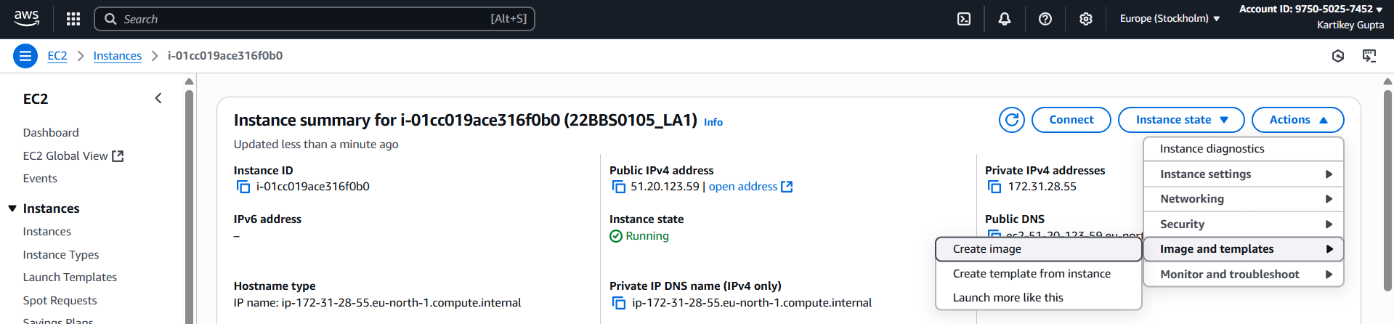
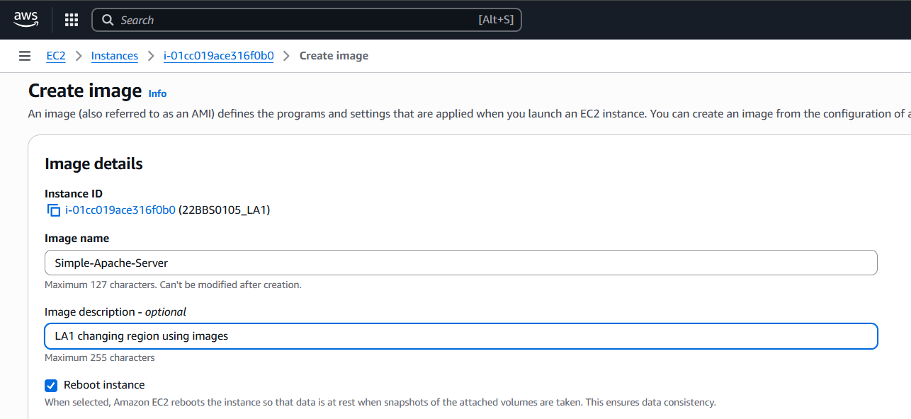
- Give a name and click Create
2. Copy AMI to Another Region
- Go to EC2 → AMIs
- Select your AMI → Actions → Copy AMI
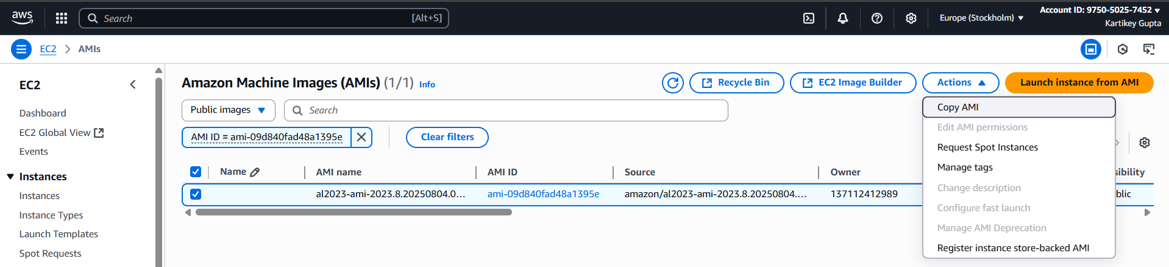
- Choose destination region (Asia Pacific Mumbai)
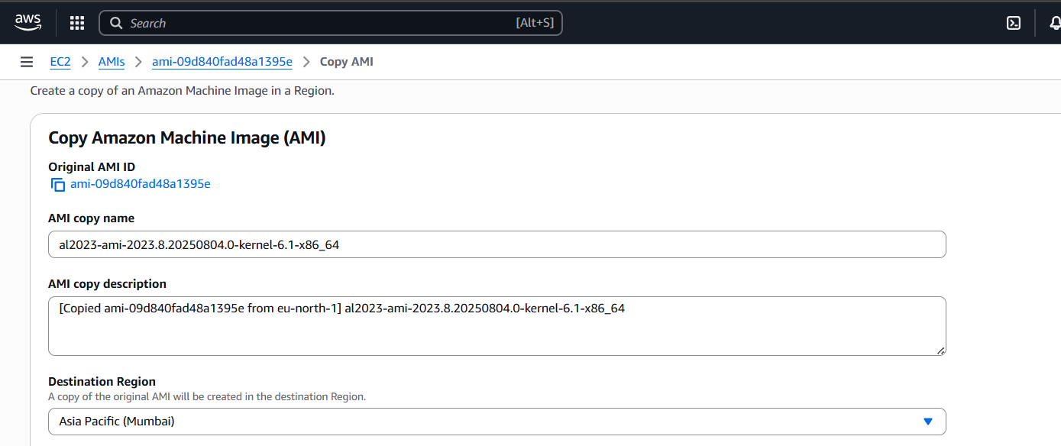
- Click Copy
3. Launch New EC2 in Another Region
- Switch region to Mumbai
- Go to AMIs → Select copied AMI → Launch instance
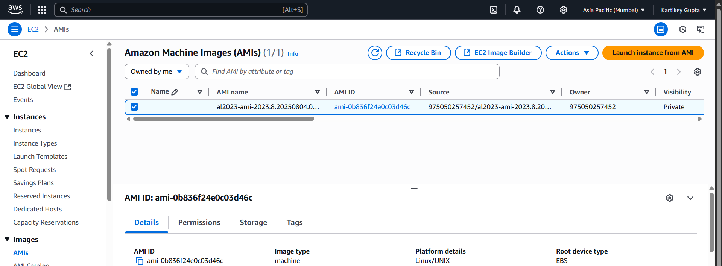
- Now app runs in the new region.
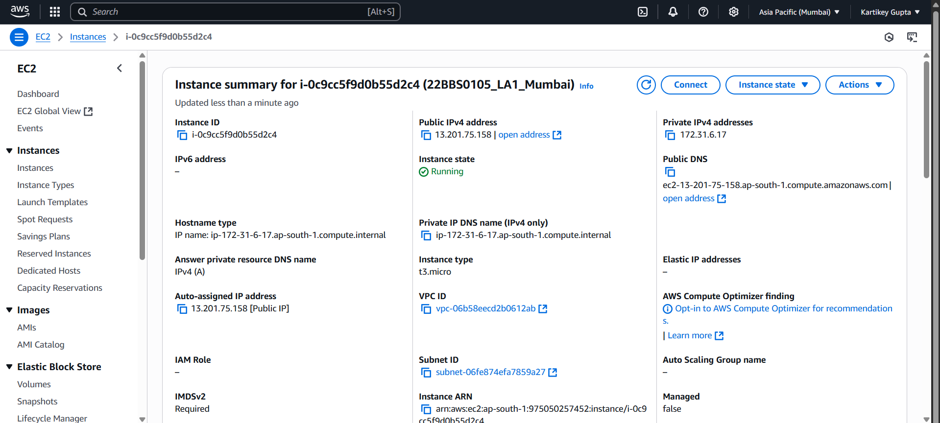

Part 3: Setup Database
Launch new instance with name DBServer following same steps above
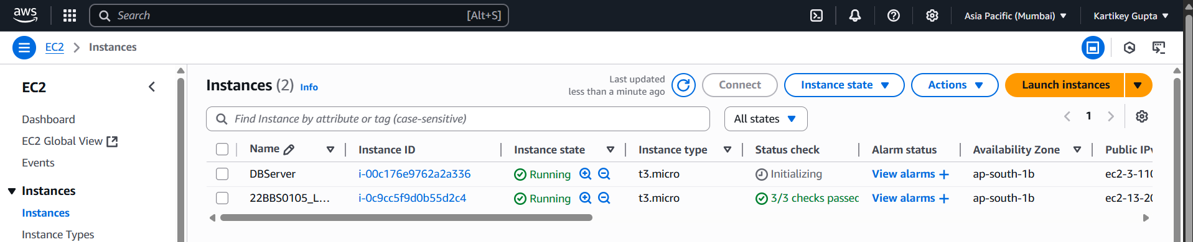
Step 1: Connecting to DBServer
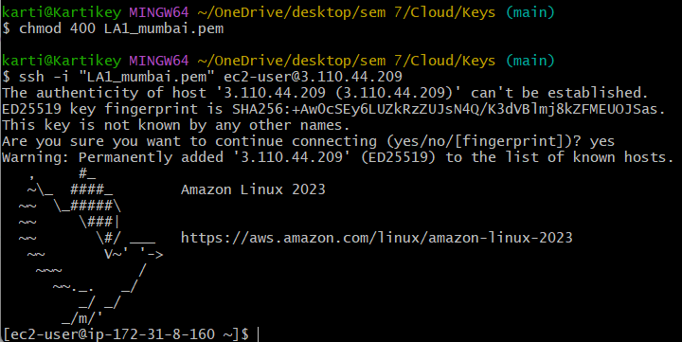
Step 2: Installing MySql
- sudo dnf update -y
- sudo dnf install mariadb105-server -y
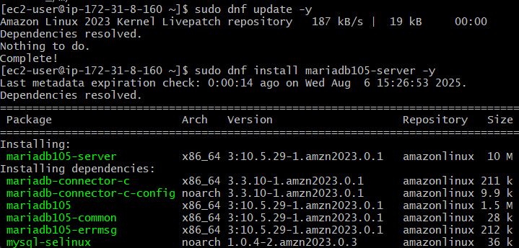
Start and enable MySQL:
- sudo systemctl start mariadb
- sudo systemctl enable mariadb
Step 3: Log in to MySQL CLI
sudo mysql -u root -p
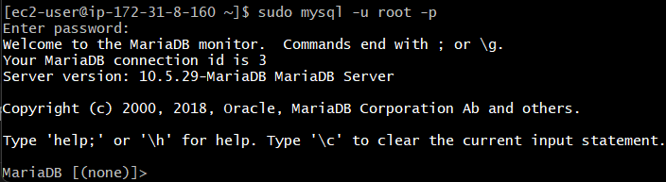
Step 4: Create Database and Table
CREATE DATABASE student;
USE student;
CREATE TABLE students (
id INT AUTO_INCREMENT PRIMARY KEY,
name VARCHAR(50),
age INT
);
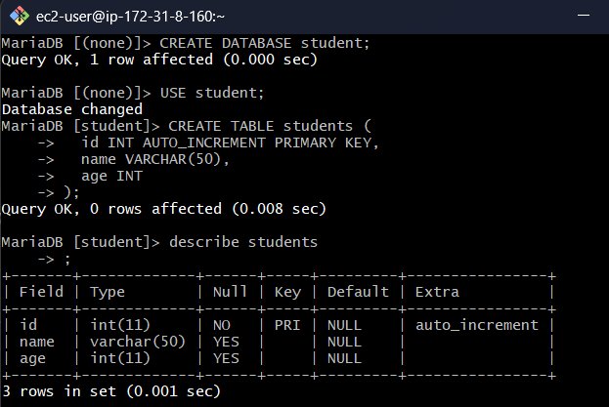
Step 5: Insert in table and display
INSERT INTO students (name, age) VALUES ('Aman', 20), ('Priya', 21), ('Ravi', 22);
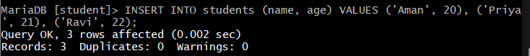
SELECT * FROM students;
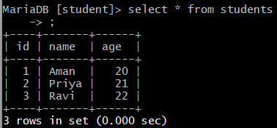
Closing connections
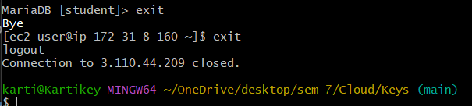

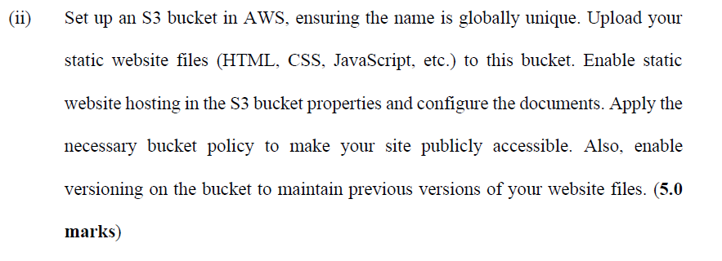
Step 1: Create an S3 Bucket
- Go to S3 Console: https://s3.console.aws.amazon.com/s3/home
- Click “Create bucket”
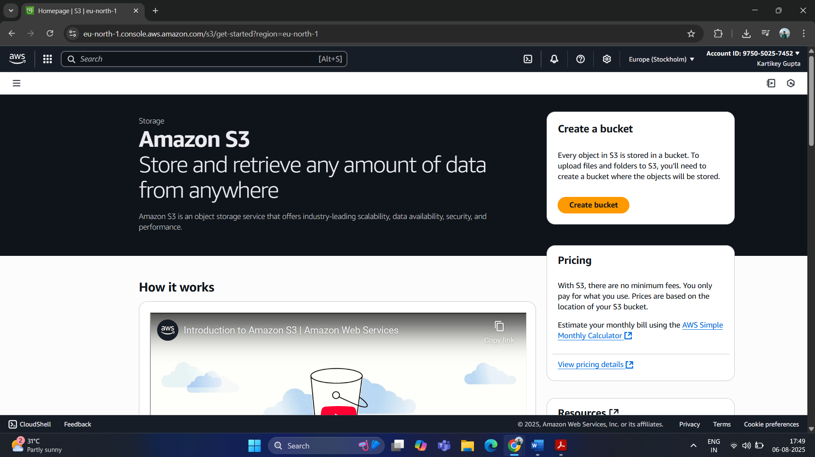
- Enter a globally unique bucket name, 22bbs0105-kartikey-la1
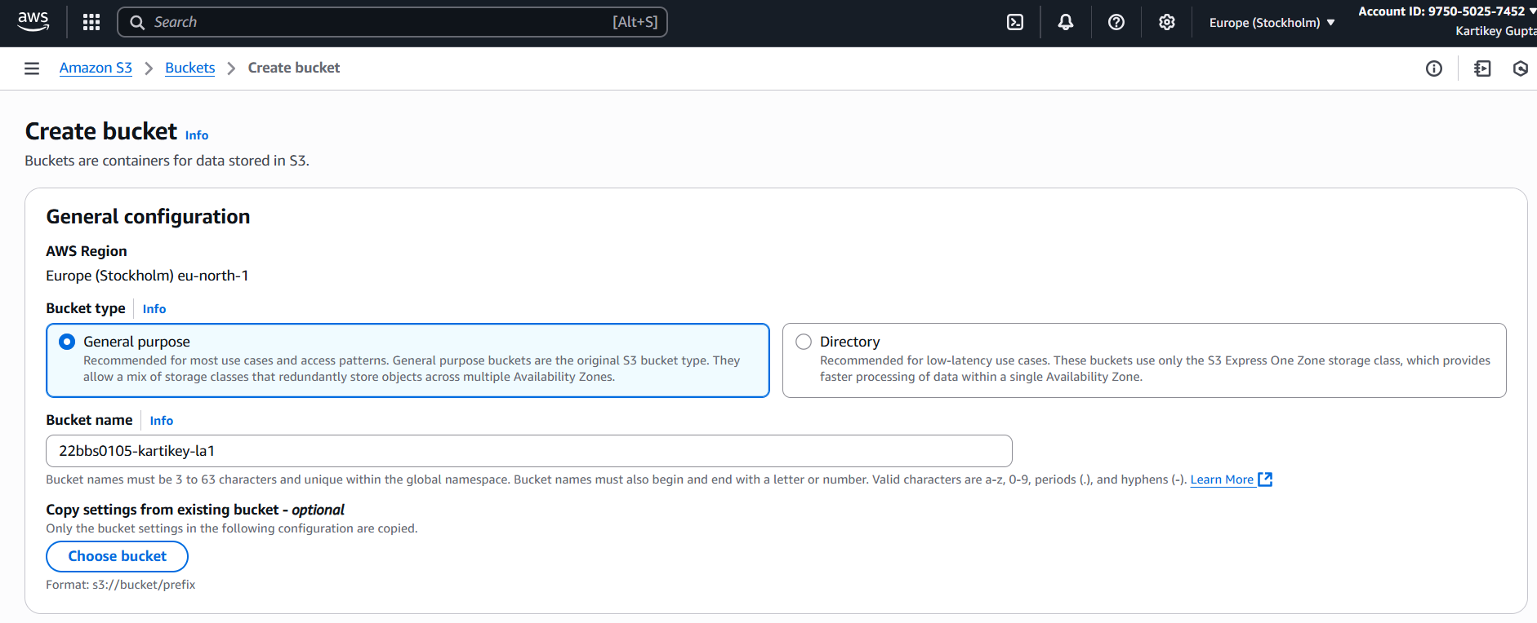
- Uncheck “Block all public access” and “Enable bucket versioning”
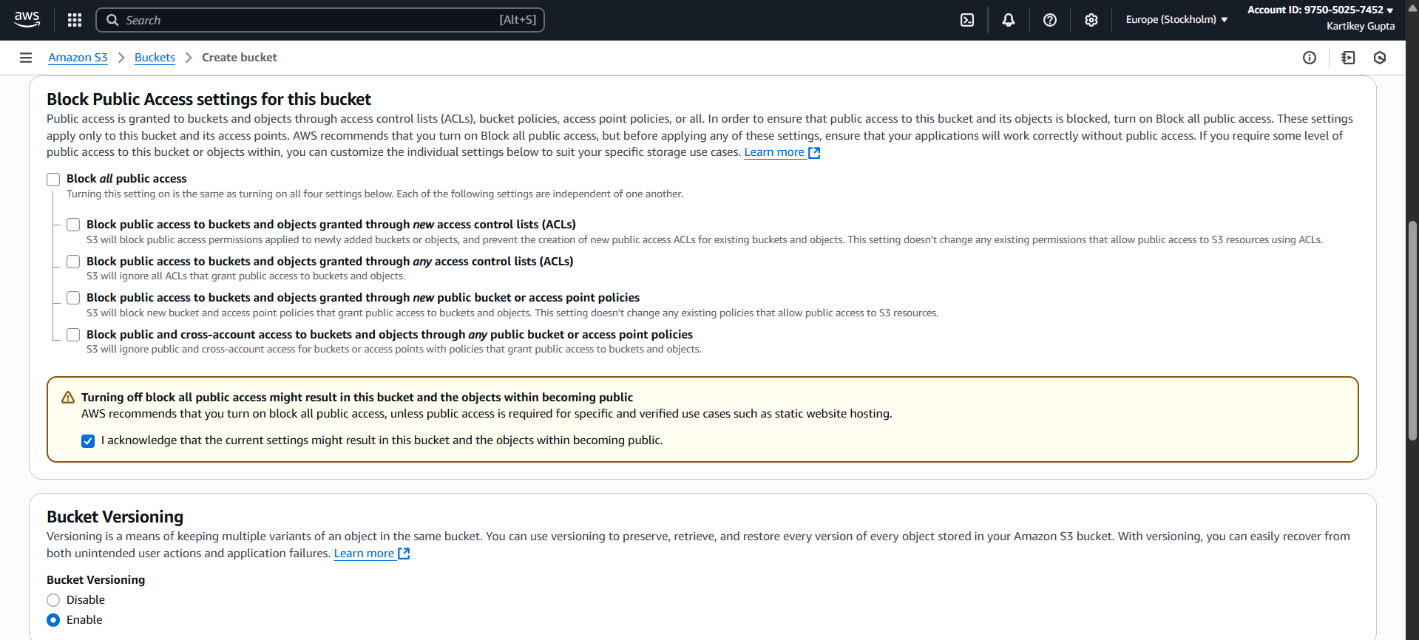
- Click “Create bucket”
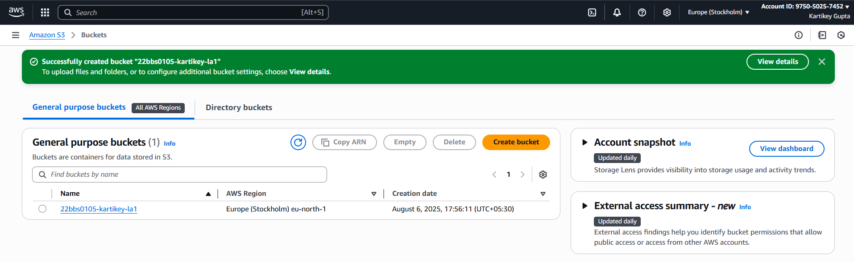
Step 2: Enable Static Website Hosting
- Go to the created bucket
- Click “Properties”
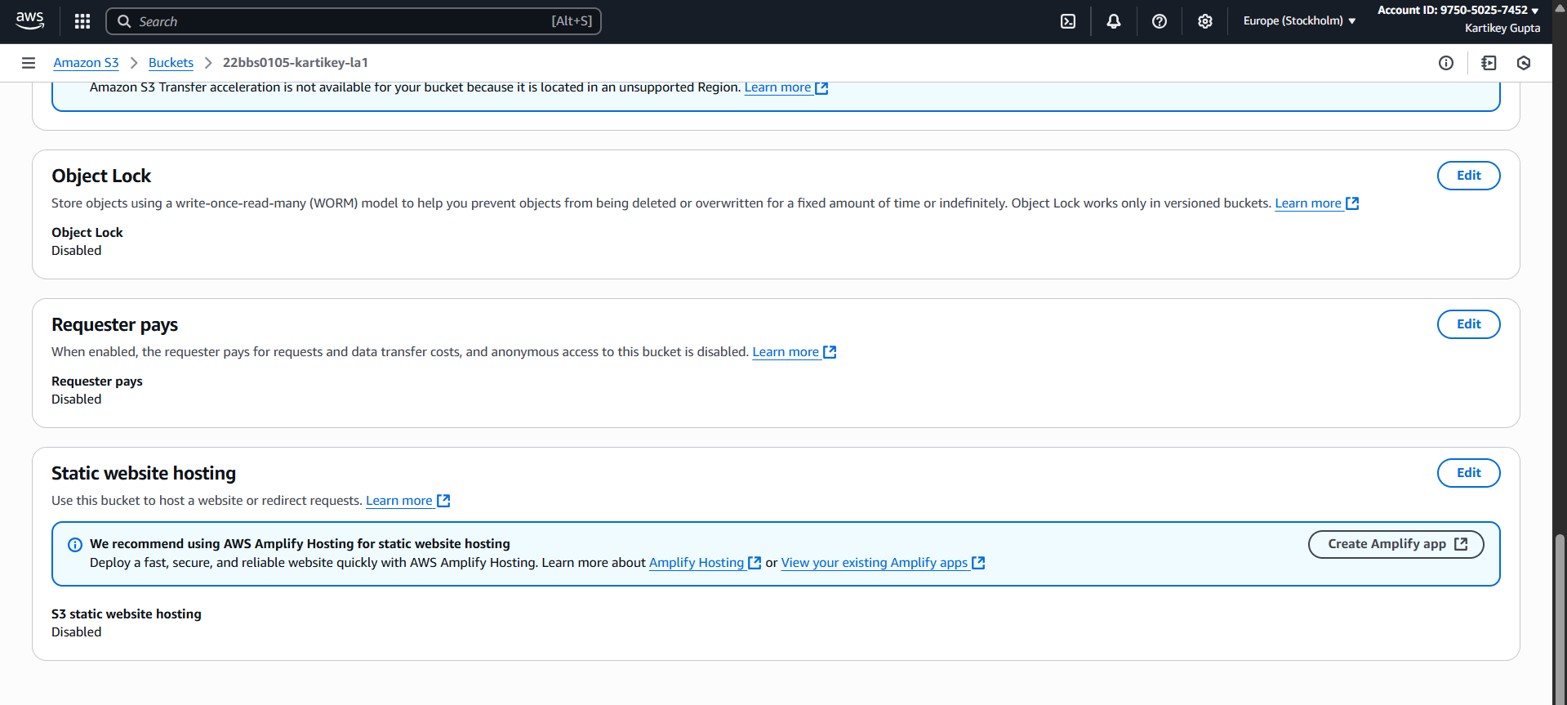
- Scroll to “Static website hosting” and enable it
- Select “Host a static website”
- Set:
  - Index document: index.html
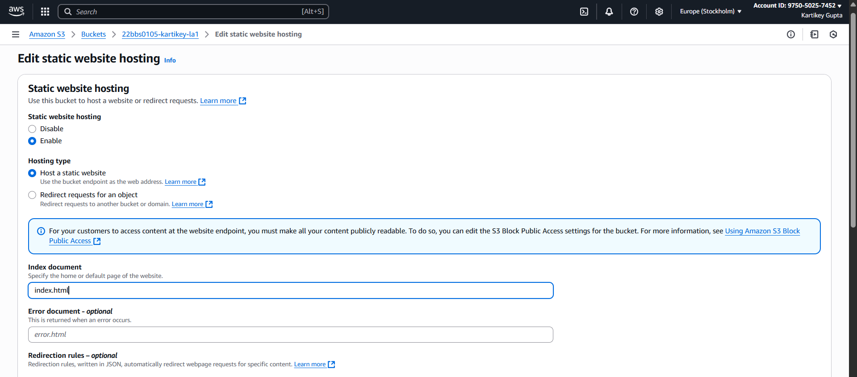
- Save changes

Step 3: Upload Website Files
- Go to the “Objects” tab in your bucket
- Click “Upload”
- Add index.html, style.css, script.js.
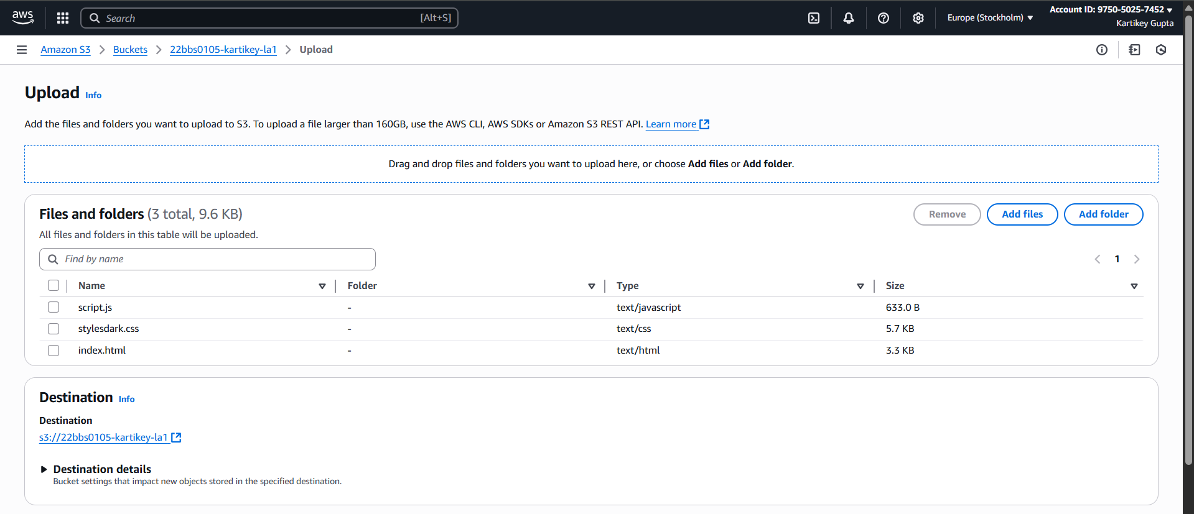
- Click “Upload”
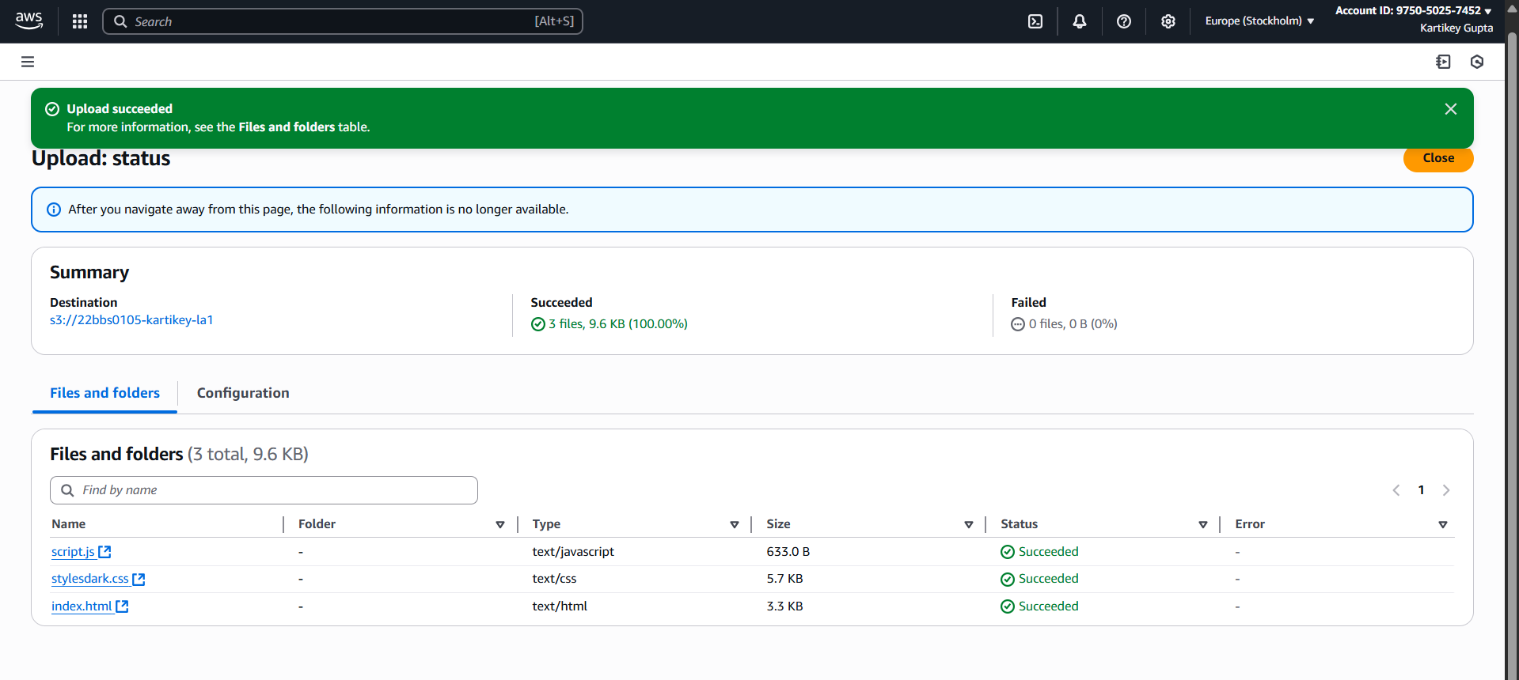

Permission Denied now
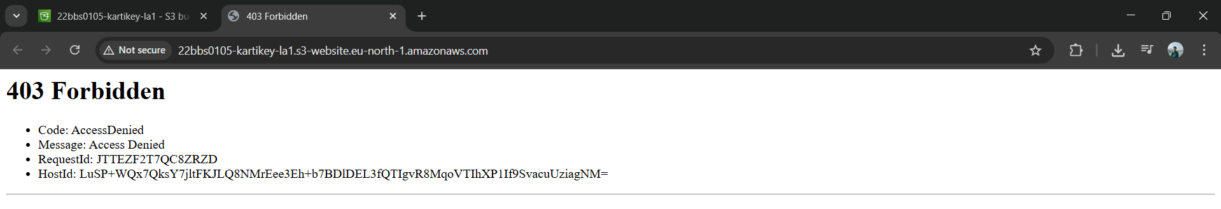
Step 4: Make Files Public (Bucket Policy)
- Go to “Permissions” tab
- Scroll to Bucket Policy
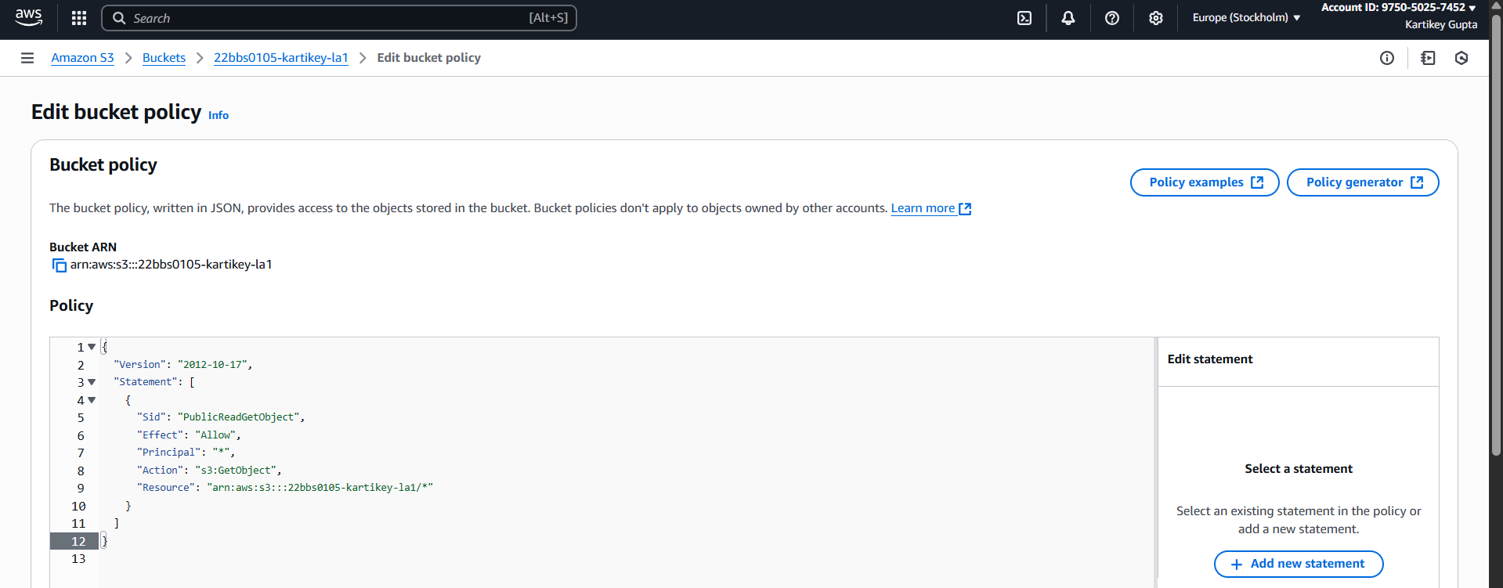

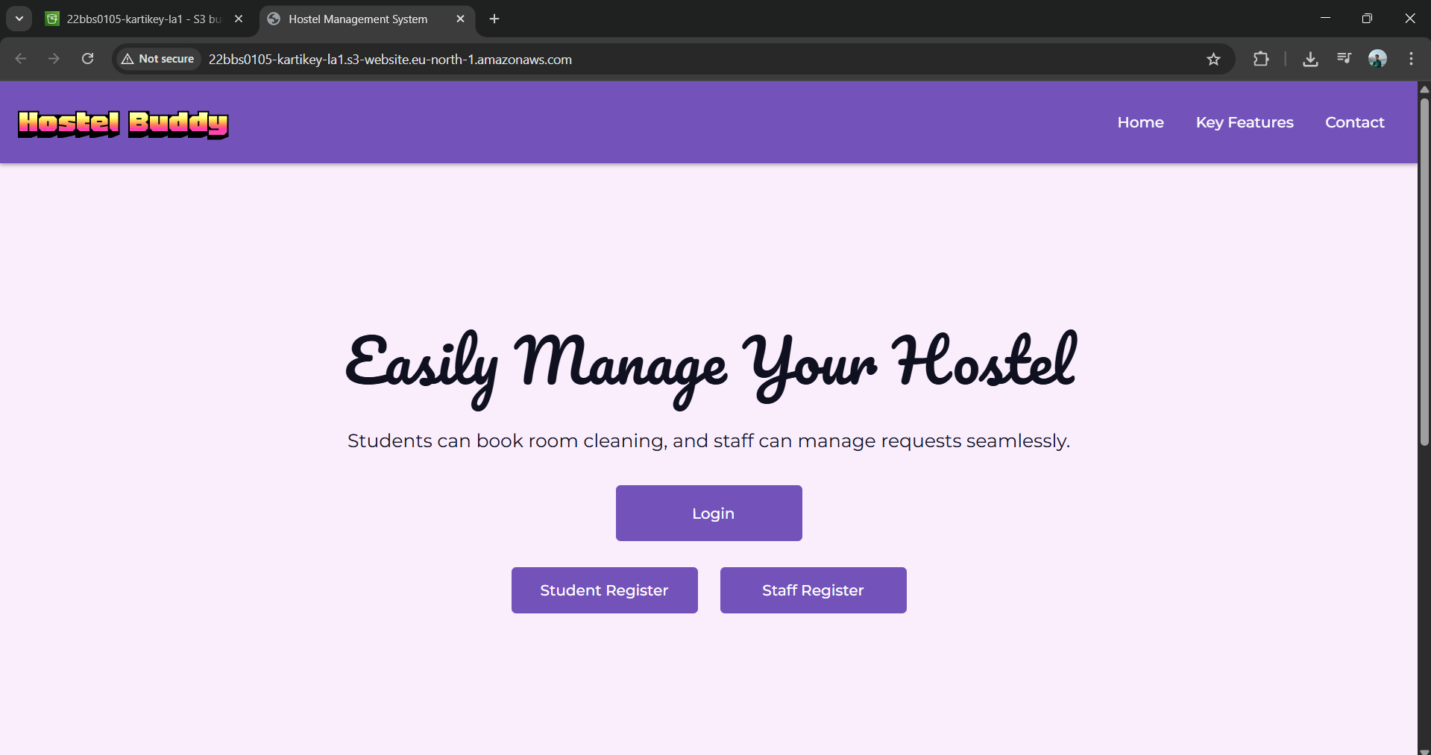
Website hosted successfully
Link: http://22bbs0105-kartikey-la1.s3-website.eu-north-1.amazonaws.com/

